IMPLEMENT RANDOM FOREST AND ANALYZE PERFORMANCE

AIM:
To implement a Random Forest Classification algorithm in Python to predict student results based on hours studied, attendance, and assignments, and evaluate the model's performance using accuracy, confusion matrix, classification report, and a feature importance graph.
ALGORITHM:
- Import the required libraries: Pandas, Matplotlib, and Scikit-learn.
- Load the dataset from data.csv.
- Select Hours_Studied, Attendance, and Assignments as input features.
- Select Result as the target variable.
- Split the dataset into training and testing sets.
- Create a Random Forest Classifier with 100 decision trees.
- Train the model using the training data.
- Predict student results using the testing data.
- Evaluate the model using accuracy, confusion matrix, and classification report.
- Calculate the importance of each feature.
- Plot a bar graph to display the feature importance.
- Display the evaluation results and graph.

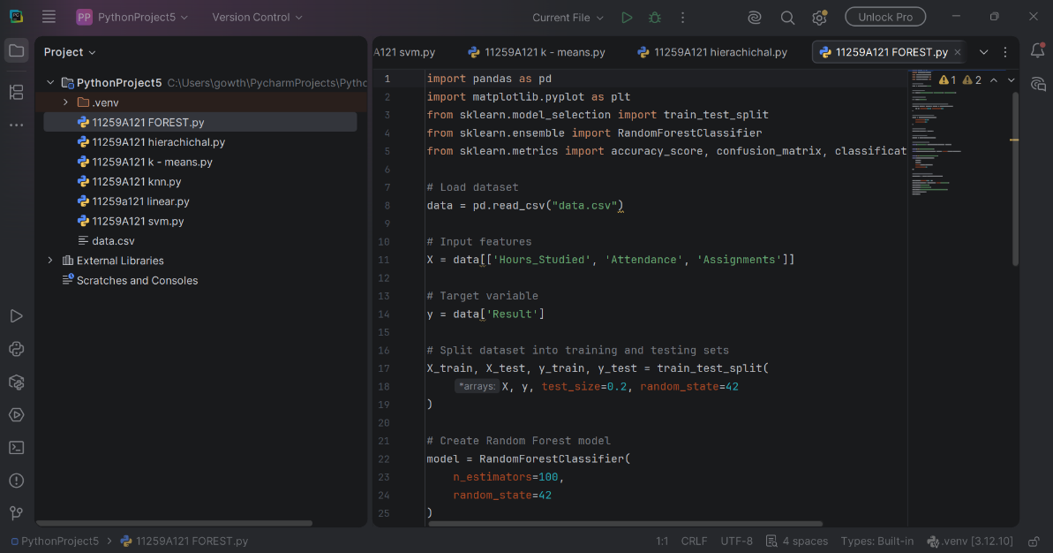

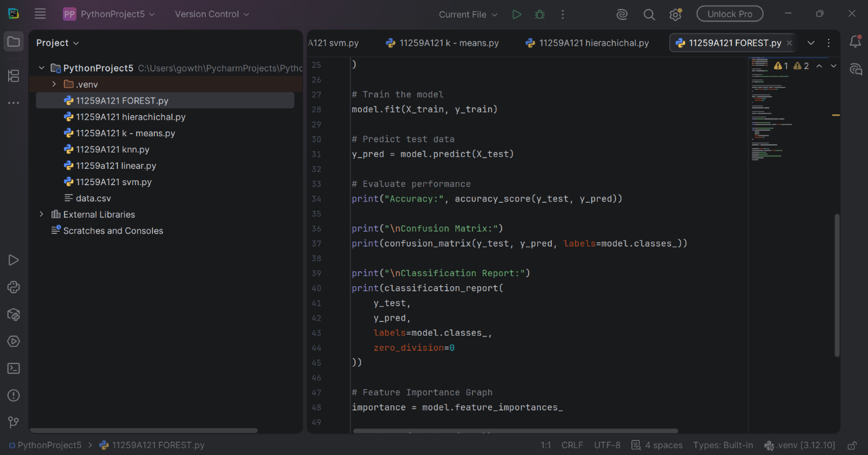
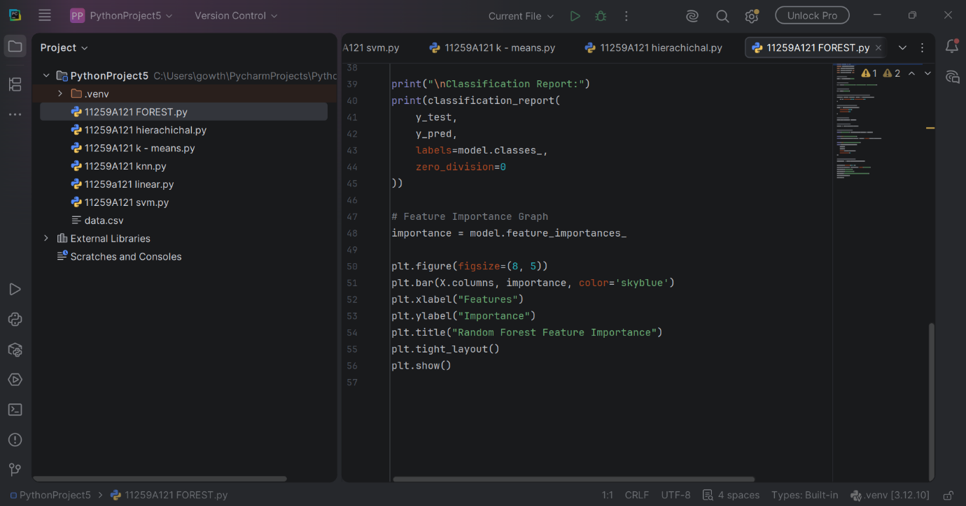
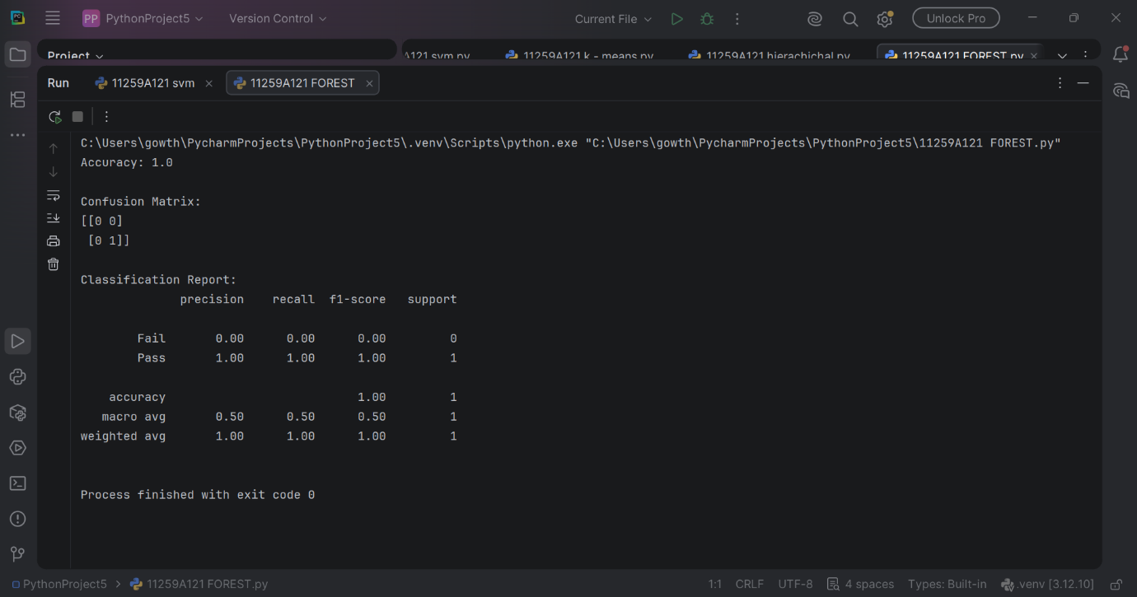

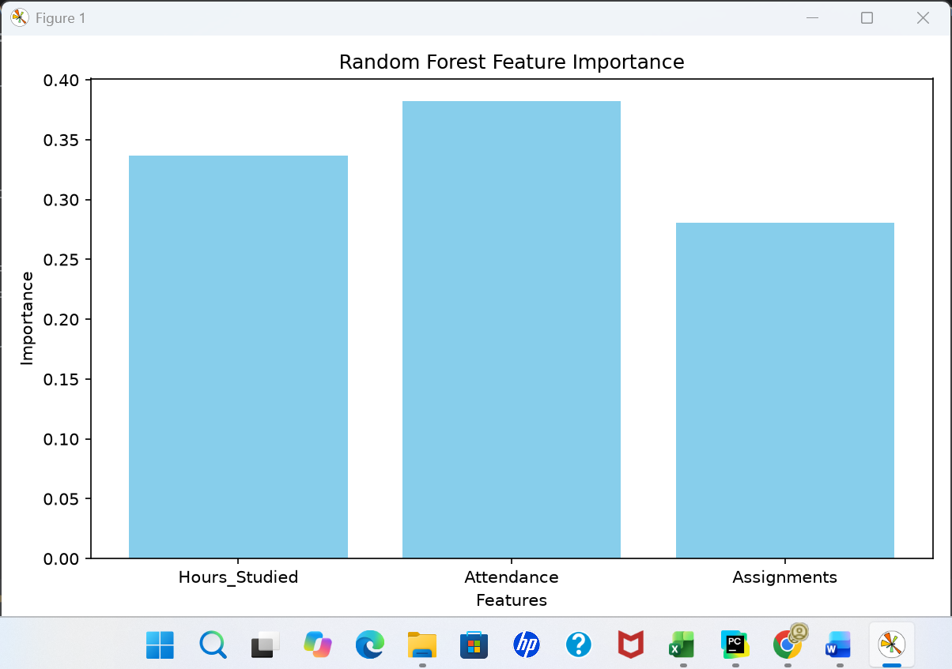

RESULT:
Thus, the Random Forest Classification algorithm was successfully implemented in Python to predict student results. The model's performance was evaluated using accuracy, confusion matrix, and classification report, and the feature importance graph was plotted successfully.

